Qlik Analysis of Road Safety and Accident Patterns in India

# Introduction

Road safety is a critical concern worldwide, and India is no exception. Despite advancements in transportation technology, the country continues to grapple with a high incidence of road accidents. These accidents result in significant loss of life and injuries, with far-reaching social and economic impacts. Addressing this issue requires a comprehensive, data-driven approach to understand the underlying factors and implement effective safety measures.

This project aims to utilize Qlik Sense, a powerful data analytics platform, to analyze road safety and accident patterns in India. By leveraging various data sources, including traffic data, accident reports, weather conditions, road infrastructure details, and demographic information, we seek to identify trends, hotspots, and factors contributing to road accidents. The insights generated from this analysis will be instrumental in helping stakeholders, such as government authorities, transportation agencies, and road safety organizations, make informed decisions to improve road safety measures, reduce accidents, and save lives.

The project will focus on three primary scenarios:

1. **Hotspot Identification**: Using Qlik's analytics capabilities to pinpoint regions or specific roads with a high frequency of accidents, correlating accident data with factors like traffic volume, road conditions, and time of day.
2. **Trend Analysis**: Performing trend analysis on historical accident data to identify patterns and recurring factors, such as types of accidents, seasonal variations, and driver behavior.
3. **Predictive Modeling**: Utilizing predictive analytics to forecast potential accident scenarios based on real-time data inputs, providing early warnings and proactive measures to prevent accidents.

By addressing these scenarios, the project aims to provide valuable insights into user demographics, accident patterns, and problem areas. These insights will support strategic planning and operational improvements, ultimately contributing to enhanced road safety in India.

# Understanding the problem

The main issue addressed is the high incidence of road accidents in India, resulting in loss of lives and injuries. The goal is to use Qlik Sense, a data analytics platform, to analyze the various causes of road accidents. By identifying patterns, hotspots and trends, the project aims to help stakeholders make informed decisions to increase road safety and reduce accidents.

# Identify the Performance Problem

## Performance problems

Despite technological advances in transportation, accidents remain a major issue in India, causing many deaths and injuries every year. A comprehensive data-driven approach is needed to understand accident patterns, identify high-risk areas, and implement effective safety measures Using Qlik Sense for this analysis will provide transferable insights have been used to improve road safety management, inform policy decisions, and ultimately save lives.

## business requirements

Interactive Dashboard: Visualize an attractive and interactive dashboard to visualize accident data.

Identify hotspots: Identify specific areas or roads where accidents are common.

Trend Analysis: Analyze historical data to identify accidents and recurring trends.

Predictive modeling: Use predictive analytics to predict potential accidents and issue early warnings.

Demographics: Provide insight into the demographics of accident victims, including age and gender distributions.

Accidents severity: Compare accident severity and traffic conditions at different locations.

Neural Analysis: Identify major causes of accidents, such as speeding or distracted driving.

Neural Analysis: Identify major causes of accidents, such as speeding or distracted driving.

Vehicle Contribution: Find the contribution of vehicles to the total number of accidents.

Annual and seasonal analysis: Find date and time series of accidental seasonal changes.

# Book Review

Conducting a literature review involves researching previous studies and reports on road safety and accident investigation. Things to consider include:

Academic databases: PubMed, IEEE Xplore, Google Scholar for peer-reviewed articles and research papers.

Government Reports: Publications and statistics from government agencies on road safety.

Institutional archives: reports and studies from travel research institutes and universities.

Previous studies: Methods, procedures used in previous studies, and data from those studies.

# social or business impact

## Social influence

Population diagram: Show the distribution of accidents in the population to understand which groups are most affected.

Accident Severity Rating: Highlight severe accident areas to prioritize safety measures.

Correlation Analysis: Examine the relationship between speed, weather, and accident rates.

Cause identification: Identify key causes of accidents to identify targeted interventions.

Victim population: Examine the age and gender distribution of accident victims in relation to awareness training programs.

The contribution of vehicles: To understand the impact of vehicles on road safety to inform laws and policies.

# A collection of information

## Collect the Dataset

For detailed analysis, the following data should be collected.

Traffic data: Information about the number, speed, and flow of traffic.

Accident Report: A detailed report of a road accident, including location, time and severity.

Weather: Historical and real-time weather data affecting road conditions.

Detailed travel information: Information on different modes, conditions and services.

Demographic Information: Information on age, sex, and other accident demographics.

## Connect Data with Qlik Sense

Data Integration: Import collected data into Qlik Sense.

Data cleaning: Clean and preprocess data to ensure integrity and accuracy.

Data modelling: Create a data model in Qlik Sense to link data types (e.g., link accident reports to traffic data and weather).

Visualization: Create interactive dashboards and visualizations for data analysis and interpretation.

Analytics: Use Qlik Sense’s analytics capabilities to identify hot spots, find trends, and create predictive models.

Reporting: Develop reports and insights to be shared with stakeholders for informed decision making.

# Data Visualizations

## Number of Unique Visualizations

The number of unique visualizations that can be created with a given dataset. Some common types of visualizations that can be used to analyse include bar charts, line charts, heat maps, scatter plots, pie charts, maps etc. These visualizations can be used to compare, track changes over time, show distribution, relationships between variables, breakdown of one category and much more.

Activity 1.1: Accidents Due to Drunken Driving

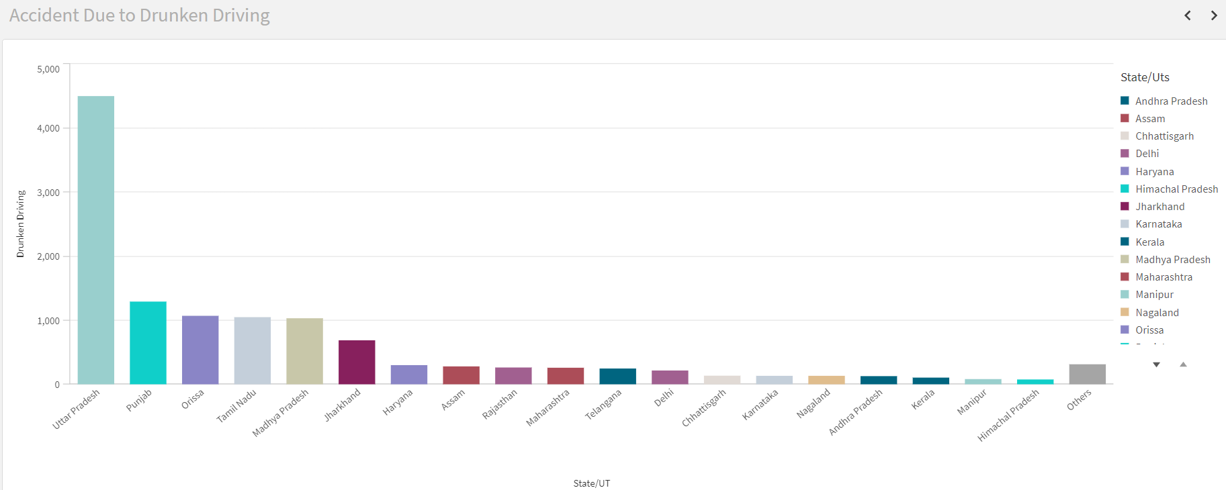

Activity 1.2: State-wise Mobile Phone Usage

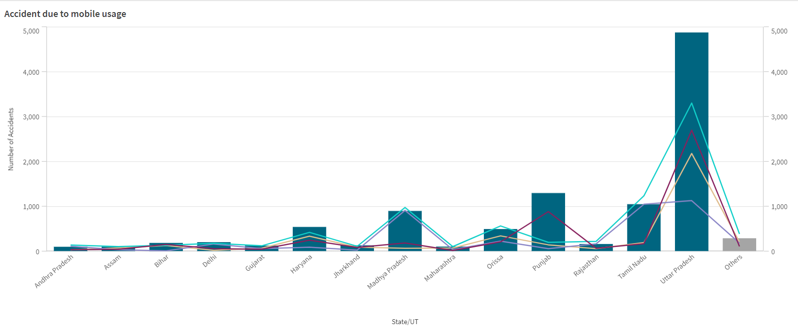

Activity 1.3: Pedestrians Killed: Age groups

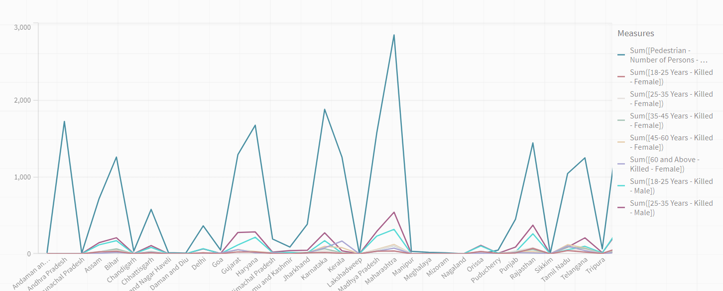

Activity 1.4: Vehicle Contribution towards Total Accidents

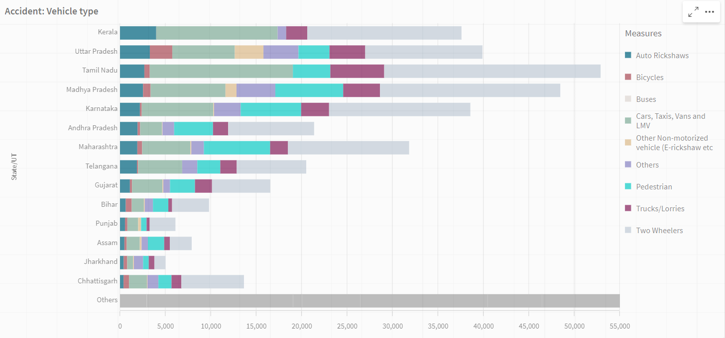

Activity 1.5: Accidents by Weather Type

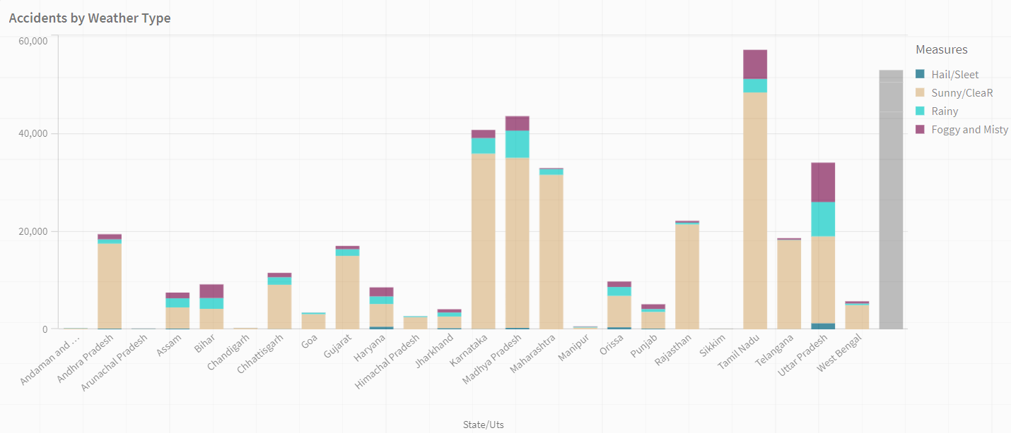

Activity 1.6: Pedestrians Killed: Gender

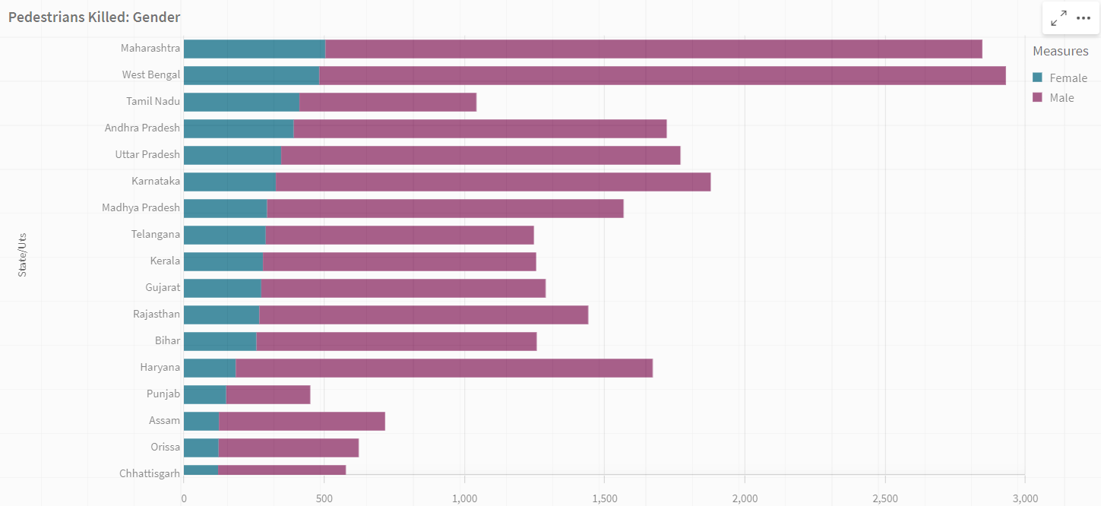

Activity 1.7: Road Users Killed: Vehicle Distribution

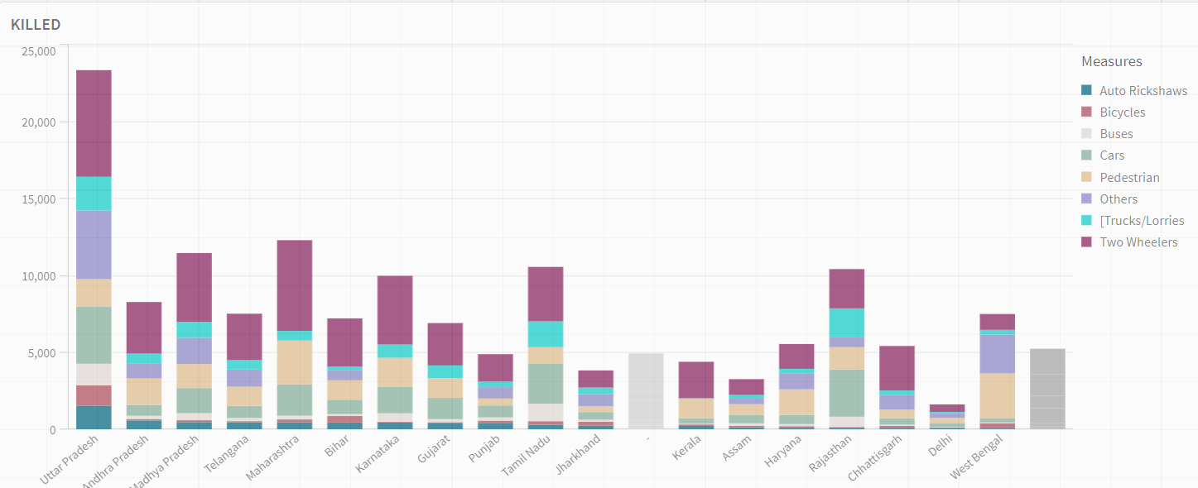

Activity 1.8: Correlation - Speeding and Number of accidents

Activity 1.9: Minors Injured across the country

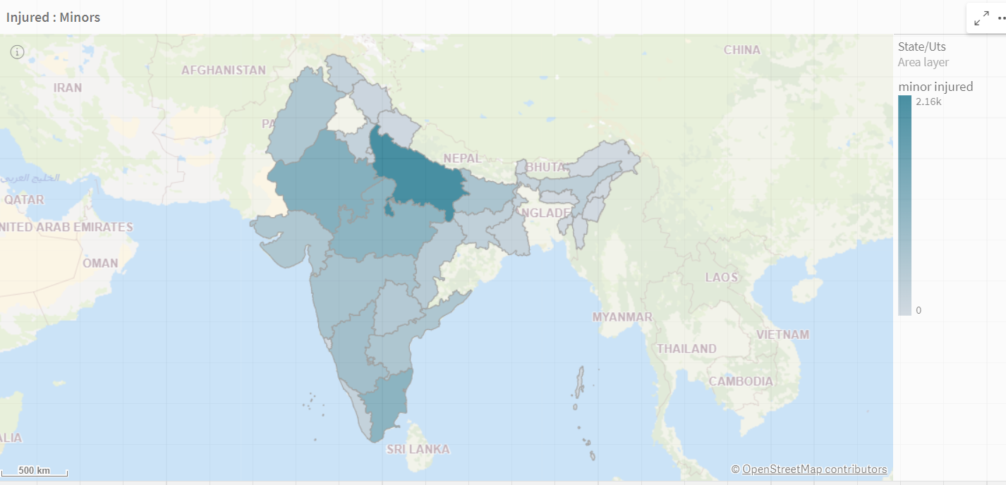

5. Responsive and Design of Dashboard

Dashboard: Accidents near Traffic Signals 

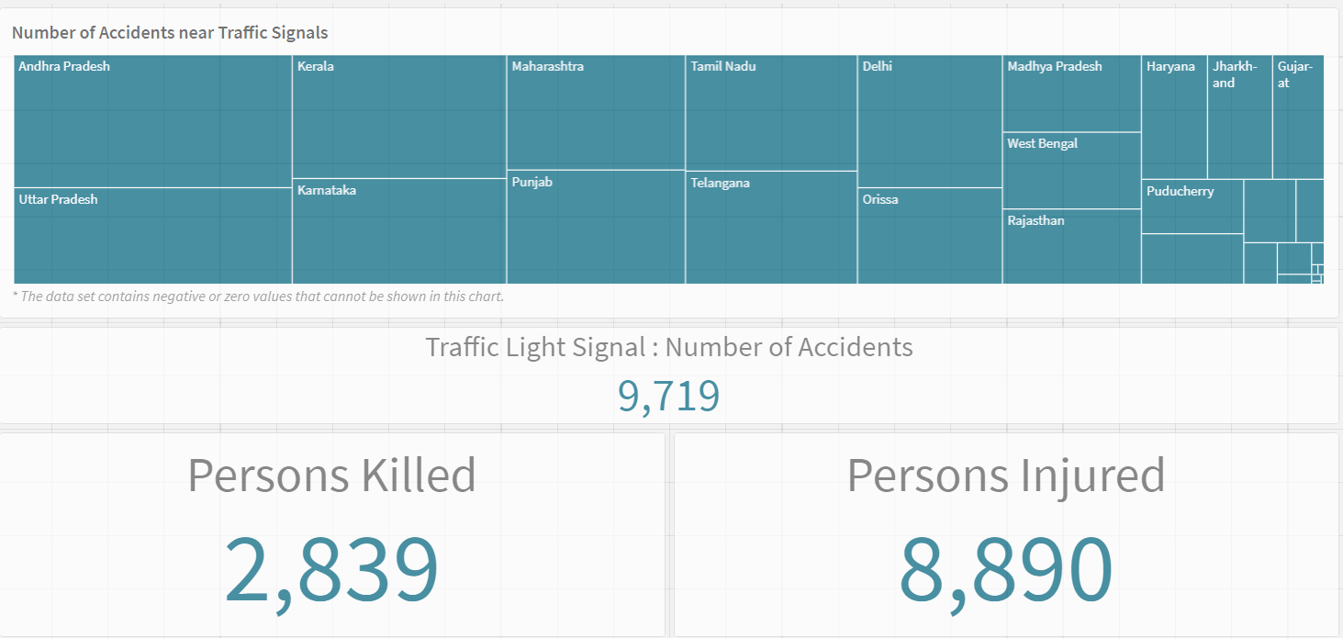

Dashboard: Accidents in Police Controlled Areas

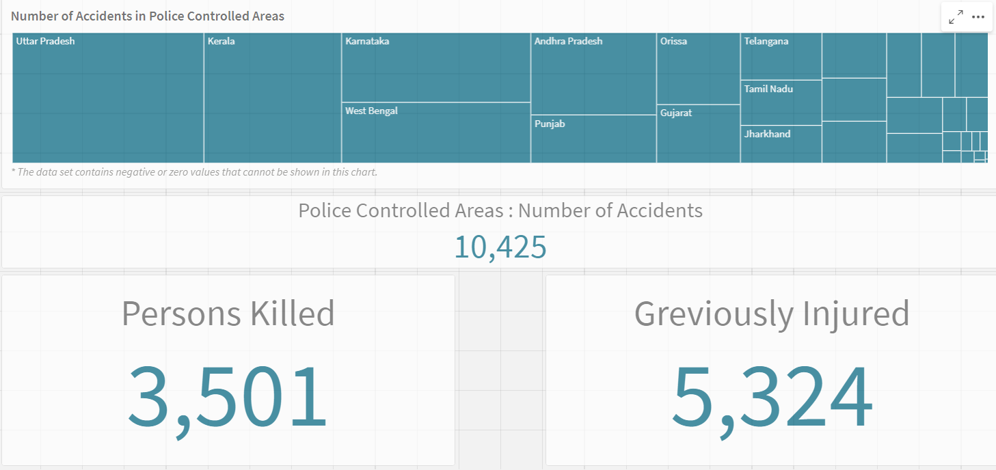

# Story Creation

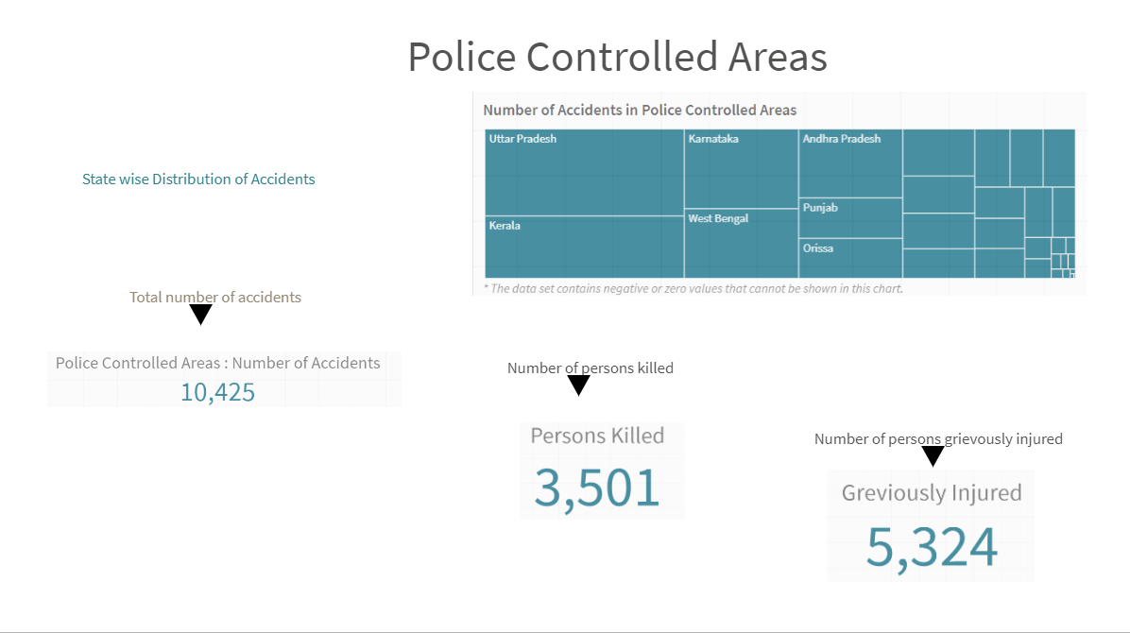

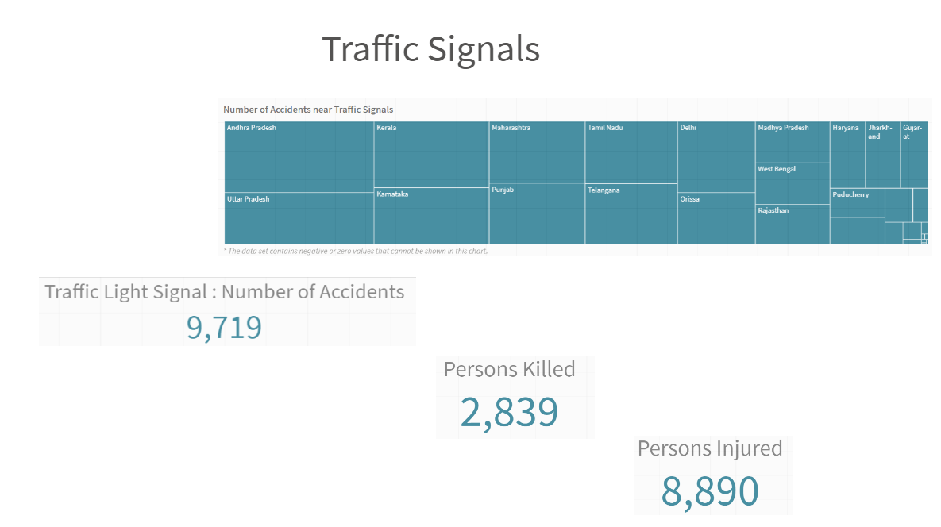

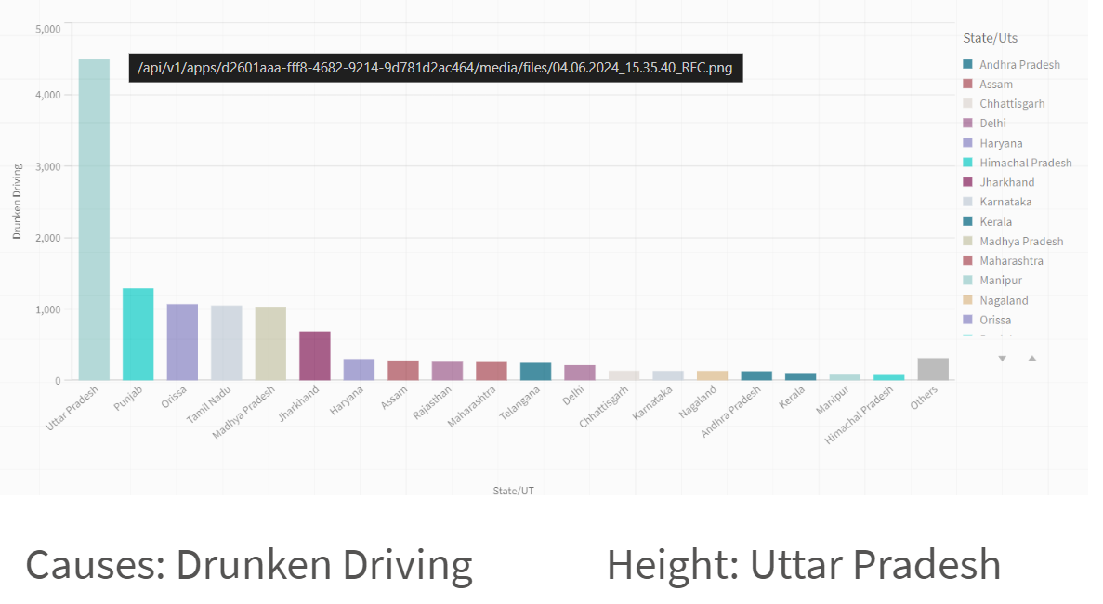

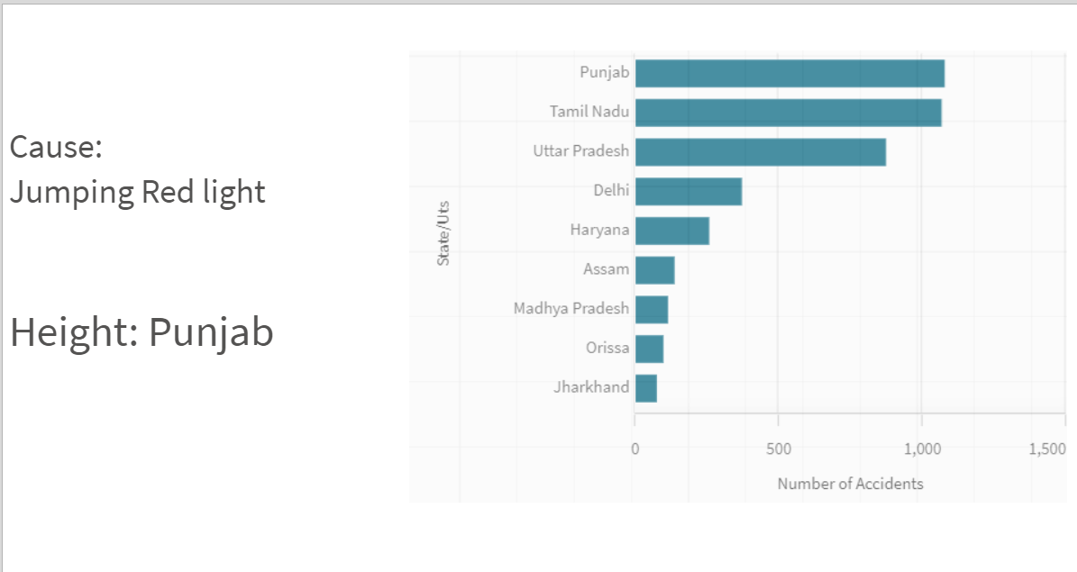

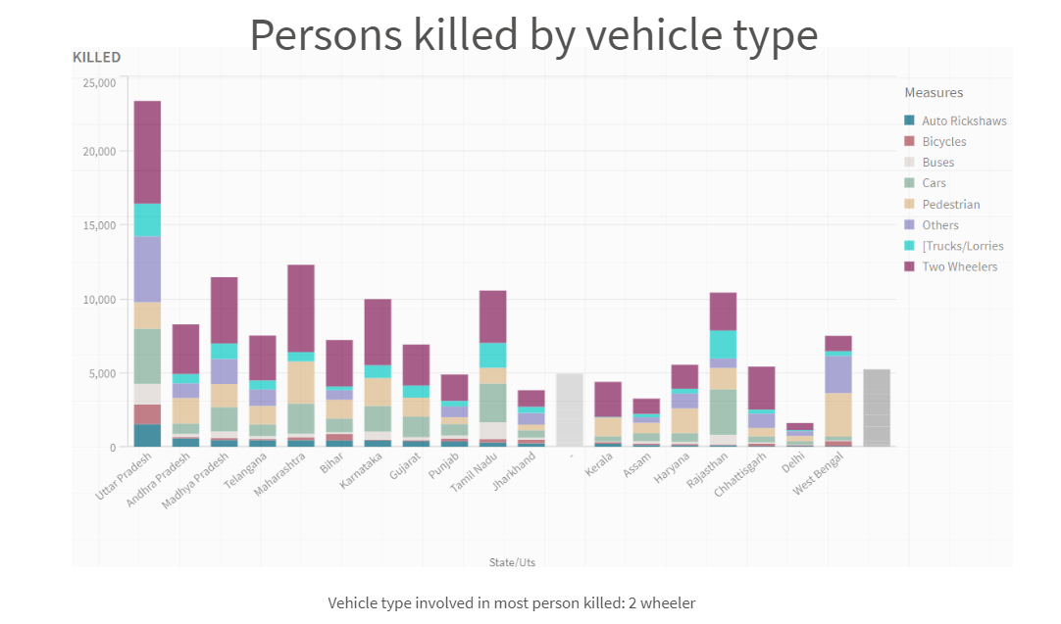

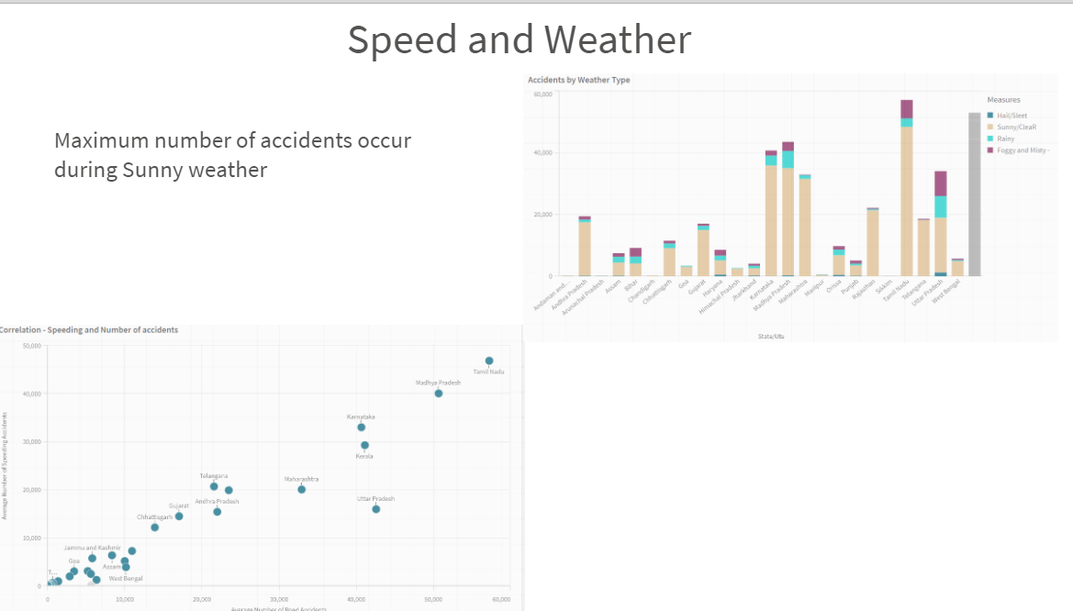

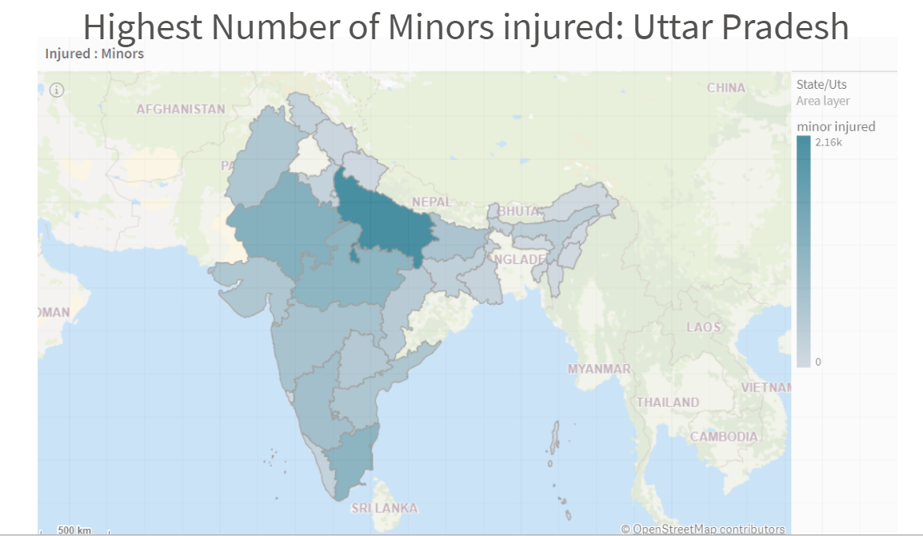

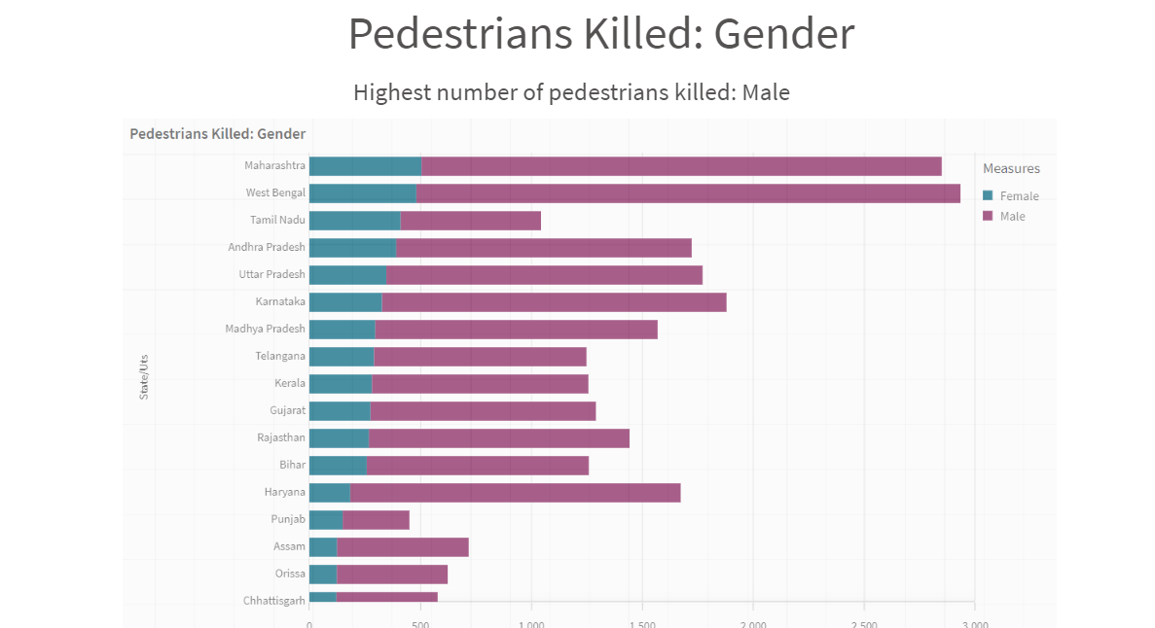

# Performance Testing

### Utilization of Data Filters

Selections within the data allows users to filter data based on individual fields or dimensions. Users can choose specific values within a field to include or exclude from analysis.Complex filters based on predefined conditions and logic can also be created.

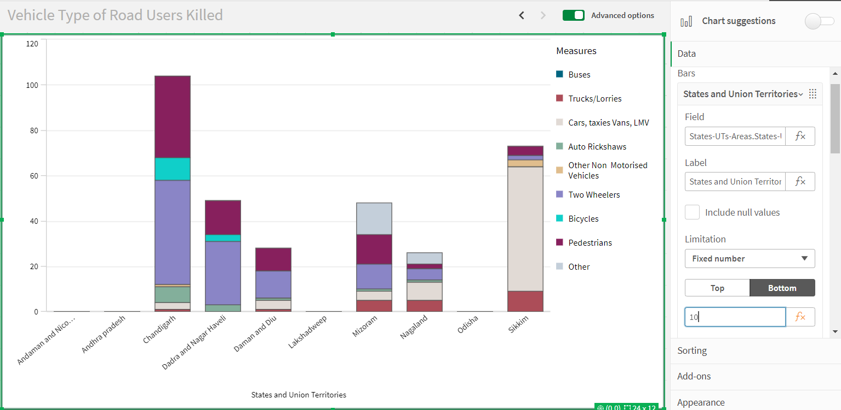

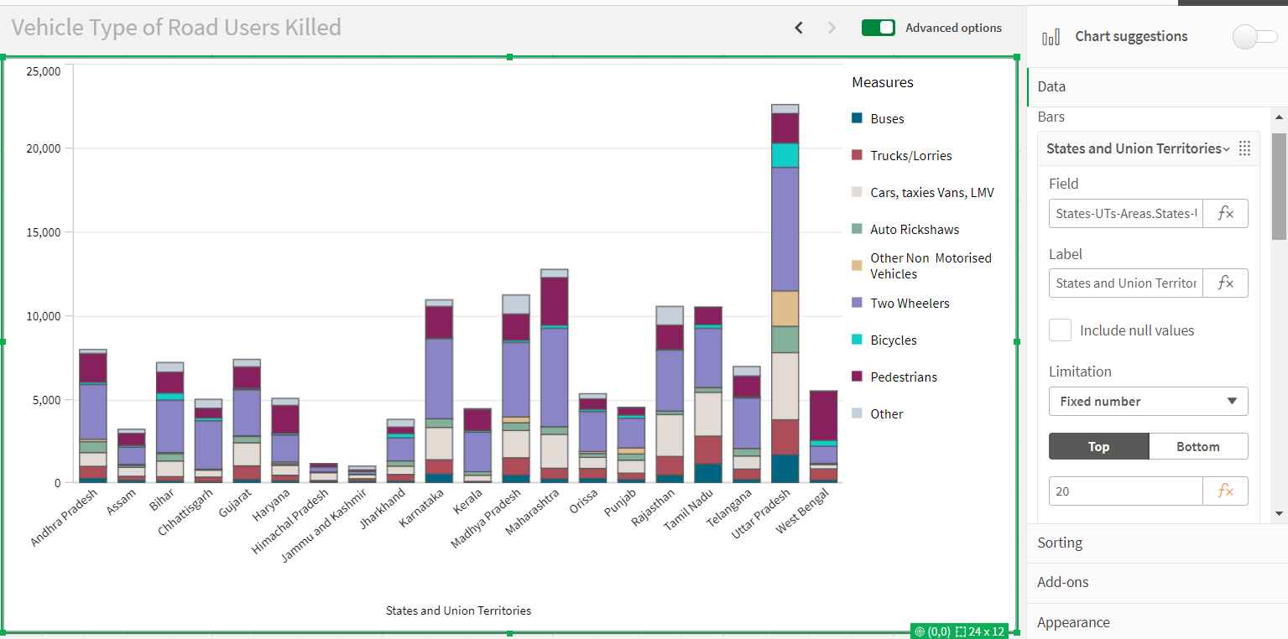

### Number of Calculation Fields/Master Items

Qlik Sense allows the creation of reusable filter objects like Master Items, Calculated Fields which can simplify the process of applying consistent filters across multiple visualizations and dashboards.

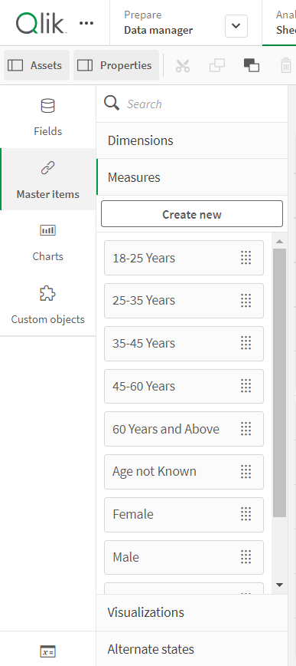

### Number of Visualizations/Graphs

1. Accidents due to Drunken Driving
2. State-wise Mobile Phone Usage
3. Vehicle Contribution towards Total Accidents
4. Correlation - Speeding and Number of accidents
5. Accidents by Weather Type
6. Minors Injured across the country
7. Pedestrians Killed: Gender
8. Pedestrians Killed: Age groups
9. Road Users Killed: Vehicle Distribution

# Conclusion

In conclusion, the analysis of road safety and accident patterns in India using Qlik Sense presents a significant opportunity to address one of the most pressing public safety issues in the country. By harnessing the power of data analytics, we can uncover critical insights that traditional methods might overlook. This project has demonstrated the potential to identify accident hotspots, understand underlying trends, and predict future incidents, enabling stakeholders to implement targeted and effective safety measures.

The integration of various data sources, such as traffic data, accident reports, weather conditions, road infrastructure details, and demographic information, provides a comprehensive view of the factors contributing to road accidents. Through interactive dashboards and visualizations, Qlik Sense empowers decision-makers with the tools they need to analyze complex data, identify problem areas, and monitor the effectiveness of implemented safety protocols.

The insights gained from this project can guide policy reforms, enhance public awareness campaigns, and inform the design of driver training programs. Furthermore, predictive modeling capabilities allow for proactive measures, potentially saving lives by preventing accidents before they occur.

Ultimately, this data-driven approach not only aims to reduce the number of road accidents and fatalities but also strives to foster a culture of road safety and responsible driving. By continuing to leverage advanced analytics and technology, India can make significant strides towards safer roads and a better future for all its citizens.

GitHub Link: <https://github.com/Arvindoffical/Road-Safety-and-Accident-Patterns-in-India.git>

Qlik Link: <https://w5mow4uamnv5ays.us.qlikcloud.com/sense/app/d2601aaa-fff8-4682-9214-9d781d2ac464>

Video Demonstration: